Specification document

Group detail 1

General use case 1

Domain class diagram 1

Project specification 2

Functionalities 2

Handle authentication 2

Use Case Specification 2

Alternative flow 1 3

Alternative flow 2 3

Alternative flow 3 3

Activity Diagram 4

Sequence Diagram 4

Examine Health data 5

Use Case Specification 5

Alternative flow 1 5

Alternative flow 2 5

Alternative flow 3 5

Activity diagram 5

Sequence Diagram 5

Handle Personal circle 5

Handle feeling form 5

Use Case Specification 5

Alternative flow 1 5

Alternative flow 2 5

Alternative flow 3 5

Activity diagram 5

Sequence diagram 5

Insert data 5

Object definitions 5

The actors 5

The type of data 5

SCRUM MASTER 5

Code 5

Register 5

Login 5

Logout 5

Retrieve 5

Add Personal circle 5

Submit Data 5

See Data 5

# Group detail

**Project name:** FlexSanté

**Github link:** <https://github.com/IUT-DEPT-INFO-UCA/gp-dam-teamflexsante/>

**GenMyModel:** <https://app.genmymodel.com/editor/edit/_r9BHIGTJEe2ck8ytUMEi6A?locale=fr>#

**Group members:**

* Lafaire Dylan
* Terzi Matis
* Vasseur Pierre-Adrien

## General use case

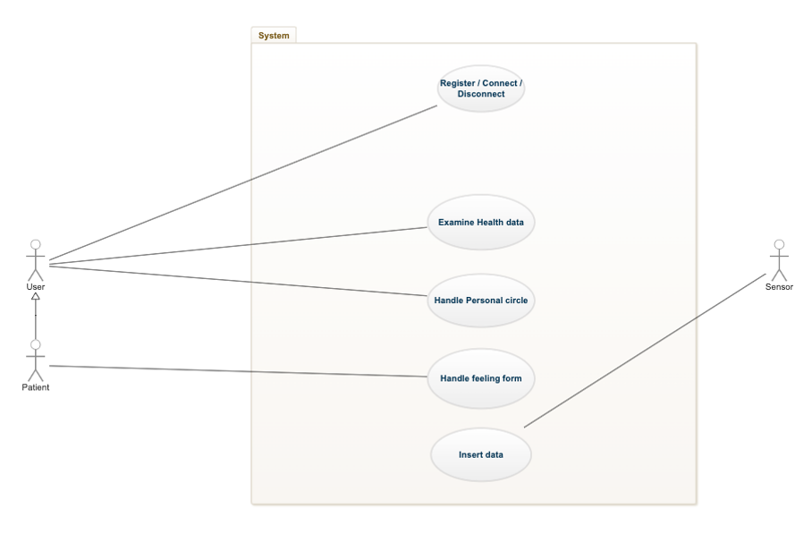

*Figure 1 - Group use case diagram*

The diagram above shows two actors on the left side. The user who is the primary user and the patient. It is important to note that there are 3 other types of actors that will be detailed in the 'Examine Health Data' use case. These actors are the doctor, the nurse and the family.

## Domain class diagram

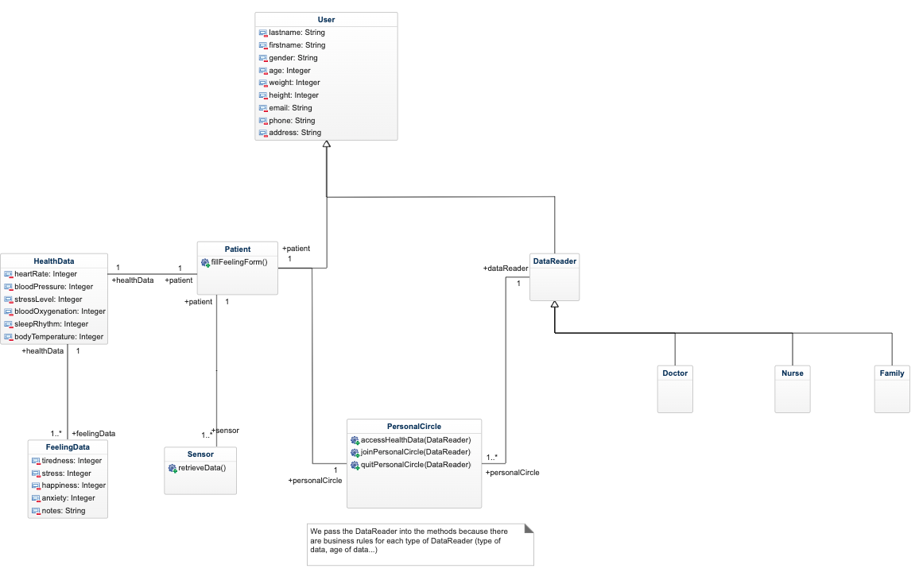

# Project specification

The following section contains the project specifications. This part is divided into 2 parts, the functionalities and the object definitions.

## Functionalities

The functionalities describe all the use cases of the project. Each use case has some specifications, diagrams...

### Handle authentication

#### Use Case Specification

|  |
| --- |
| Use Case: Handle authentication |
| Description: The user can login, register and disconnect from the platform. |
| Principal actor: User |
| Prerequisite: The user must have a valid email |
| Principal flow:   1. The user register into the platform with personal information 2. The user login into the platform with his email and password 3. The user disconnects from the platform after using it |
| Postconditions:   1. The user is saved in database. |
| Alternative flow:   1. The user already exists in the database (email taken) 2. The password in invalid (not strong enough) 3. Connectivity problem |

##### Alternative flow 1

|  |
| --- |
| Alternative flow: Handle authentication: The user already exists in the database |
| Description: The email provided by the user is already taken by an existing user in the database |
| Principal actor: User |
| Prerequisite: The user has tried to register in the platform. |
| Flow:   * The alternative flow begins when the user tries to submit his personal information to submit into the platform. * The system shows a toaster with an error message to inform the user that this email his already taken. * The system highlights invalid or missing input in the form. |
| Postconditions: None |

##### Alternative flow 2

|  |
| --- |
| Alternative flow: Handle authentication: The password in invalid |
| Description: The password provided by the user is not strong enough to pass validation. |
| Principal actor: User |
| Prerequisite: The user has tried to register in the platform |
| Flow:   * The alternative flow begins when the user tries to submit the form at step 3. * The system shows a toaster with an error message to inform the user that the password provided is not strong enough. * The system highlights invalid input with some help to comply for validation. |
| Postconditions: None |

##### Alternative flow 3

|  |
| --- |
| Alternative flow: Handle authentication: Connectivity problem |
| Description: The user loses his connexion while register / login / disconnect |
| Principal actor: User |
| Prerequisite: A patient has tried to register/login/disconnect from the platform, but his connexion was lost. |
| Flow:   * The alternative flow begins when the user tries to register, login, disconnect from the platform. * The system shows a toaster with an error message that says to retry when the connexion is available. |
| Postconditions: None |

#### Activity Diagram

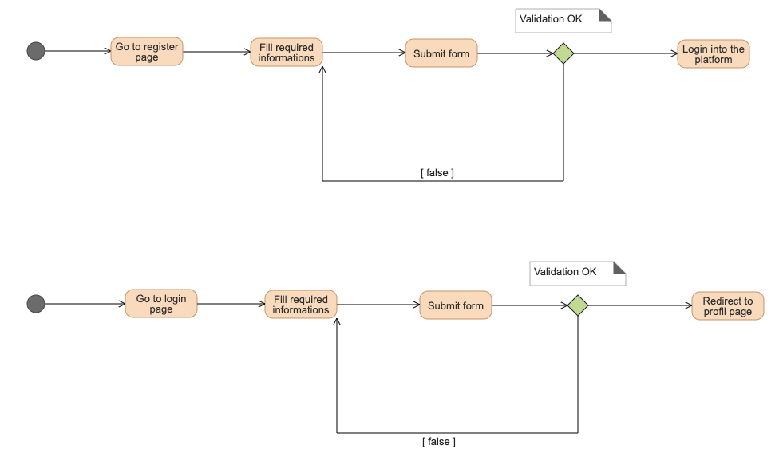

#### Sequence Diagram

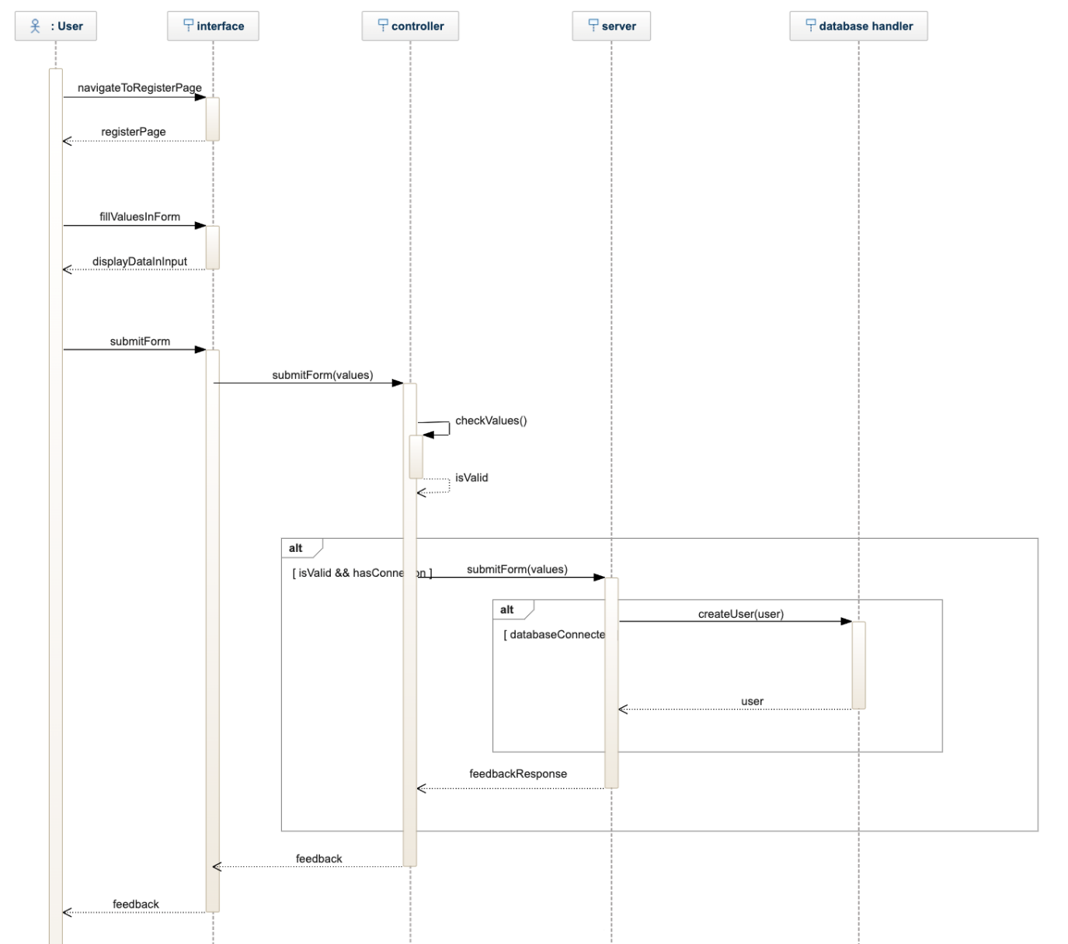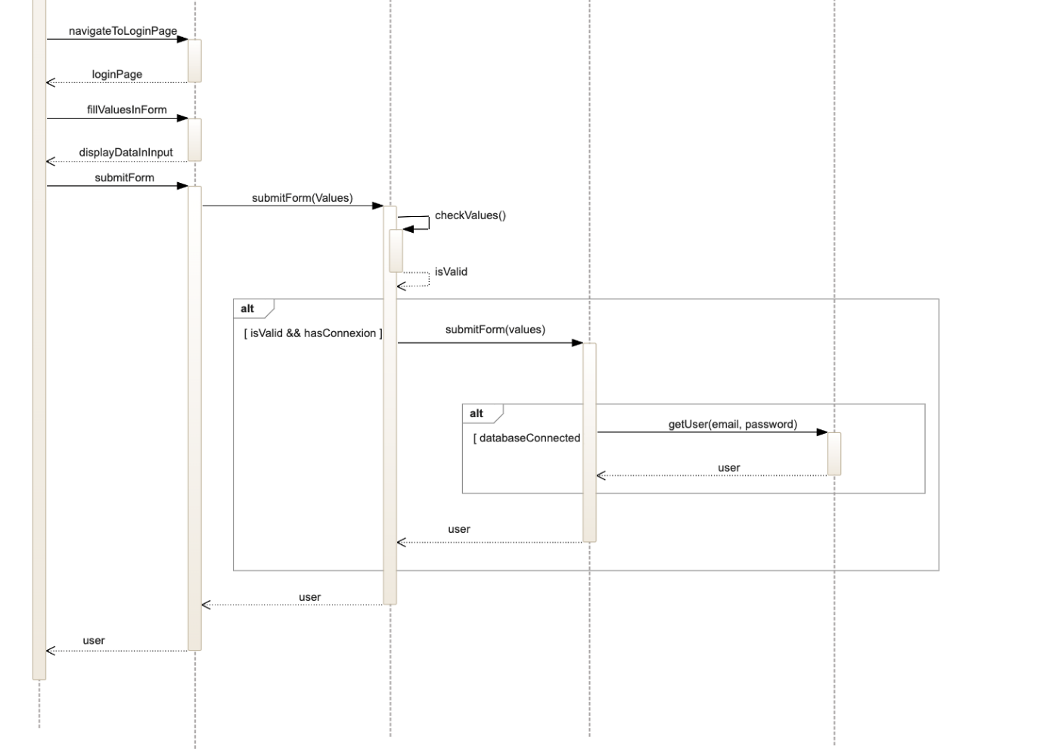

### Examine Health data

#### Use Case Specification

|  |
| --- |
| Use Case : Handle Health Data |
| Description: The actor can see the Health Data of a Patient |
| Principal Actor : User |
| Prerequisite : A valid User is connected to the platform |
| Principal flow:   1. The use case begins when the user navigates to the health data tab when connected. 2. The Data Reader choose his patient. 3. The Data Reader select period to examine 4. The Data Reader examine the data |
| Postconditions: None |
| Alternative Flow:   1. The user loses his connexion before going to the tab. 2. Due to server-side problem, the health data values cannot be showed. 3. The user has no patient linked to him |

##### Alternative flow 1

|  |
| --- |
| Alternative Flow : Handle Health Data The user loses his connexion before going to the tab. |
| Description: The user loses his connexion before going into the tab. |
| Principal Actor : User |
| Prerequisite: A patient has tried to go into the health data tab, but his connexion was lost before going into it. |
| Flow:  - The alternative flow begins when the user tries to go into the health data tab at step 1.  - The system shows a toaster with an error message that says to retry when the connexion is available.  - The user will have to try going into the page again when the connexion is back. |
| Postconditions: None |

##### Alternative flow 2

|  |
| --- |
| Alternative Flow : Handle Health Data Due to server-side problem, the health data values cannot be showed |
| Description: Due to server-side problem, the health data values cannot be showed |
| Principal Actor : Data Reader |
| Prerequisite: A patient has tried to go into the health data tab select a patient, and a period to examine, but Due to server-side problem, the health data values cannot be showed |
| Flow:  - The alternative flow begins when the user tries to go into the health data tab, select a patient, and a period to examine at step 3.  - The system shows a toaster with an error message that says to retry when the connexion is available.  - The user will have to try going into the page, select a patient, and a period to examine to see the data again when the connexion is back. |
| Postconditions: None |

##### Alternative flow 3

|  |
| --- |
| Alternative Flow : Handle Health Data The user has no patient linked to him |
| Description: The user has no patient linked to him |
| Principal Actor : Data Reader |
| Prerequisite: A patient has tried to go into the health data tab but the user has no patient linked to him |
| Flow:  - The alternative flow begins when the user after going into the health data tab at step 1.  - The system shows a toaster with an error message that says the he has no patient linked  - The user will have add a patient to have access to his health data. |
| Postconditions: None |

#### Activity diagram

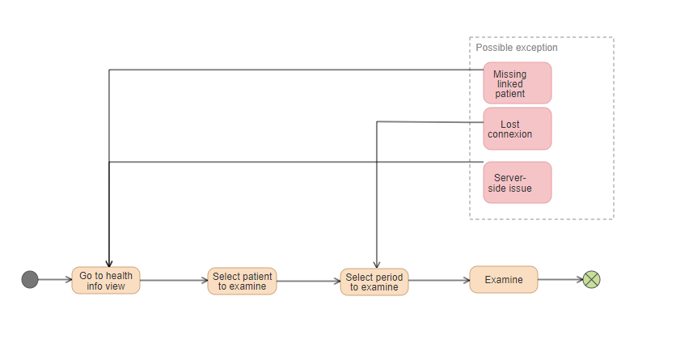

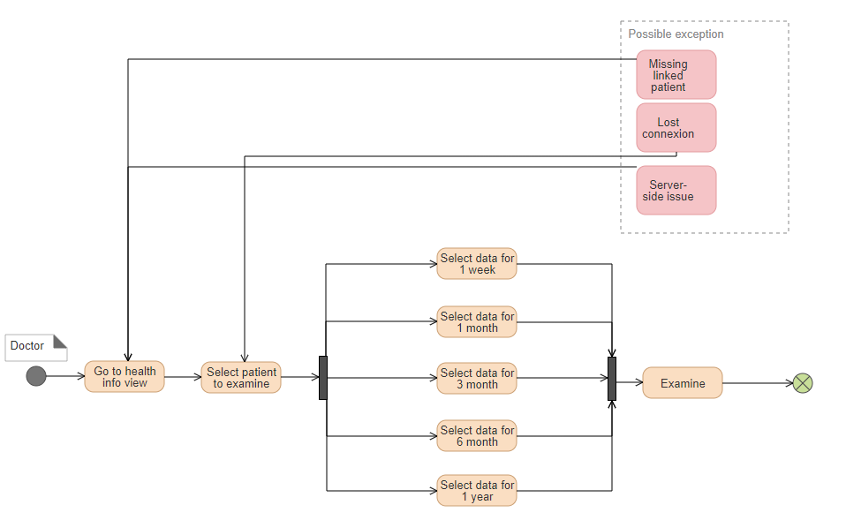

#### Sequence Diagram

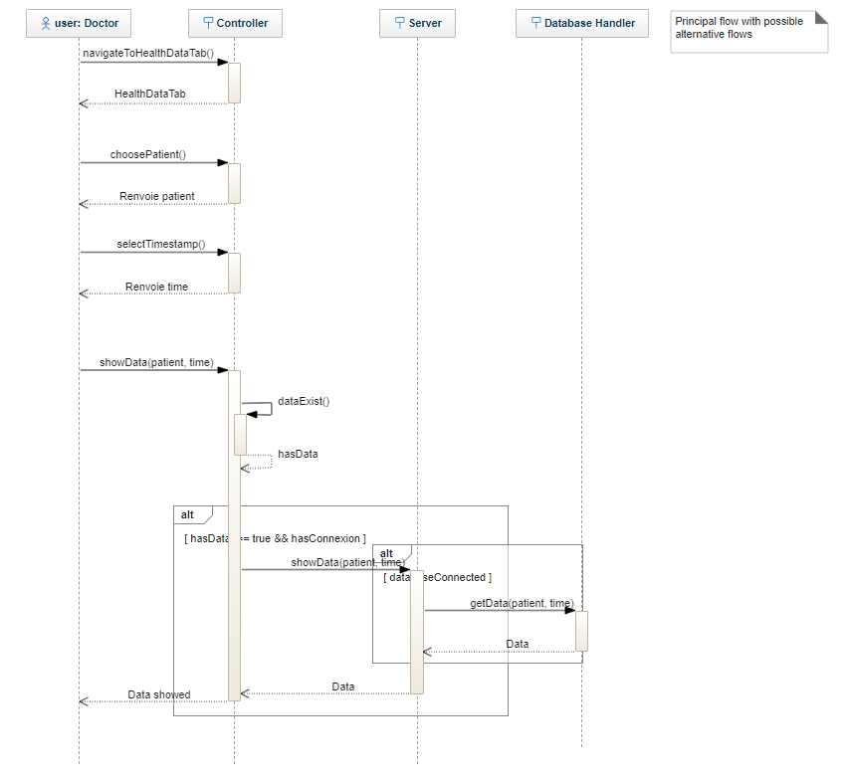

### Handle Personal circle

#### Use Case Specification

|  |
| --- |
| Use Case: personal circle |
| Description: Customer goes to the personal circle view |
| Principal actor: Customer |
| Prerequisite: A valid Customer is connected to the platform |
| Principal flow:   1. The use case starts when the client goes to the personal circle tab 2. The customer adds or removes a person in his circle 3. If the client has no one in his circle he cannot remove people 4. If he makes a mistake in the person's email, he receives a pop-up 5. The customer must fill in the email of the person who wants to add/remove |
| Postconditions:   1. A person was added and removed from your personal circle |
| Alternative flow:   1. mail not found 2. cannot be deleted 3. no internet access |

##### Alternative flow 1

|  |
| --- |
| Alternative flow: email not found |
| Description: email not found when adding member to circle |
| Principal actor: Customer |
| Prerequisite: The email entered is invalid. |
| Flow:   * Alternate flow starts at ‘added people’ step. * The system displays a message indicating that the email is not valid * Go back to 'added people' |
| Postconditions: None |

##### Alternative flow 2

|  |
| --- |
| Alternative flow:  cannot be deleted |
| Description: when there is no one in the family circle deletion is not possible |
| Principal actor: Customer |
| Prerequisite: Empty personal circle . |
| Flow:   * Alternate stream starts at 'removed people' step * The system displays a message indicating that the deletion cannot take place * Go back to the personal circle tab |
| Postconditions: None |

##### Alternative flow 3

|  |
| --- |
| Alternative flow: no internet access |
| Description:  the device is no longer connected to the internet. |
| Principal actor: Customer |
| Prerequisite: don’t have a internet connection. |
| Flow:   * Alternate feed starts on page load * a popup appears with the message “you have been in offline mode” * Go back to the personal circle tab but in offline mode. |
| Postconditions: None |

#### Activity diagram

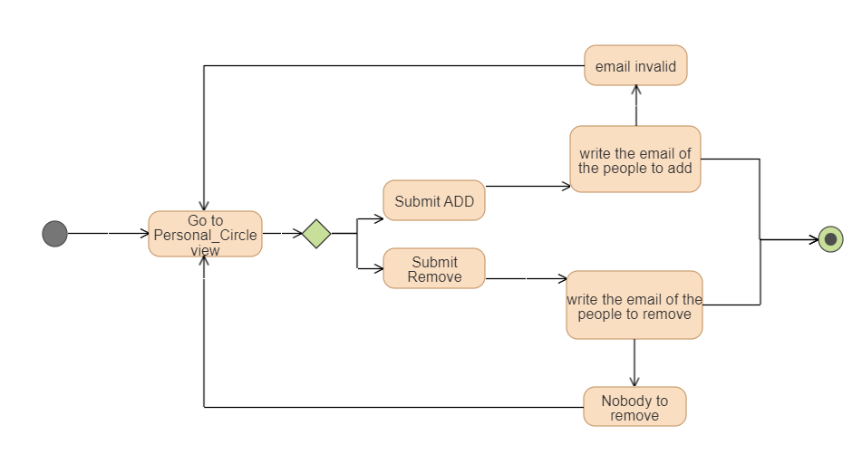

#### Sequence diagram

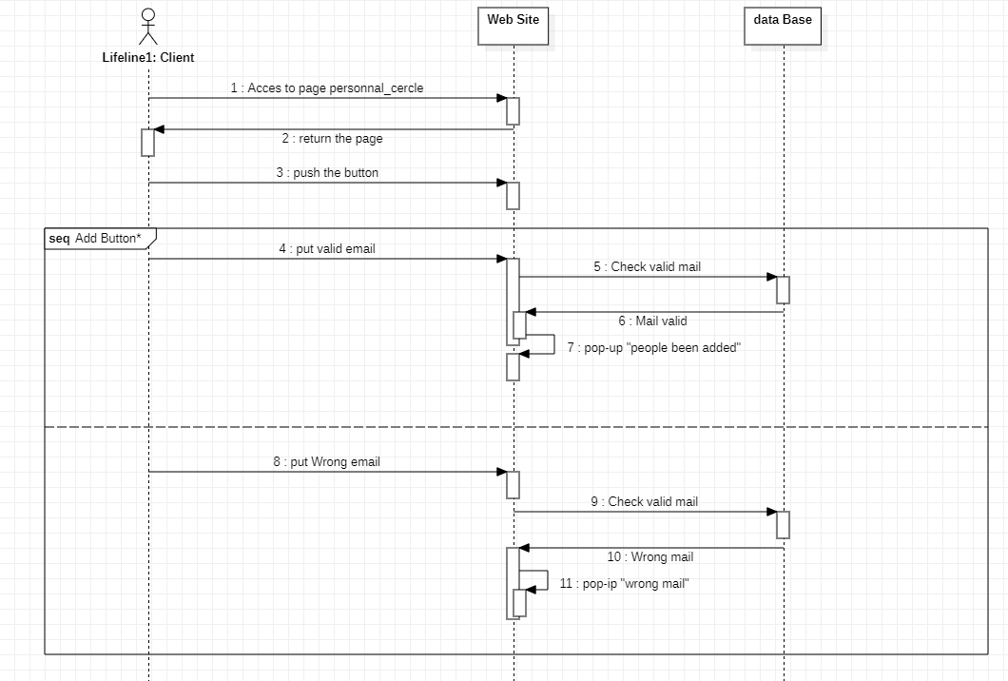

### Insert data

User put email and submit

## Object definitions

In this part, we will add people on the user Personal Circle

### The actors

**User:** The general user of the platform Patient, Nurse, Doctor, Family Member.

**WEB Site:** the web site where the personal circle page is available, it as the “front” of the web site.

**Database:** regroup database and the rest API, it as the “back” of the web site.

#### Sequence diagram

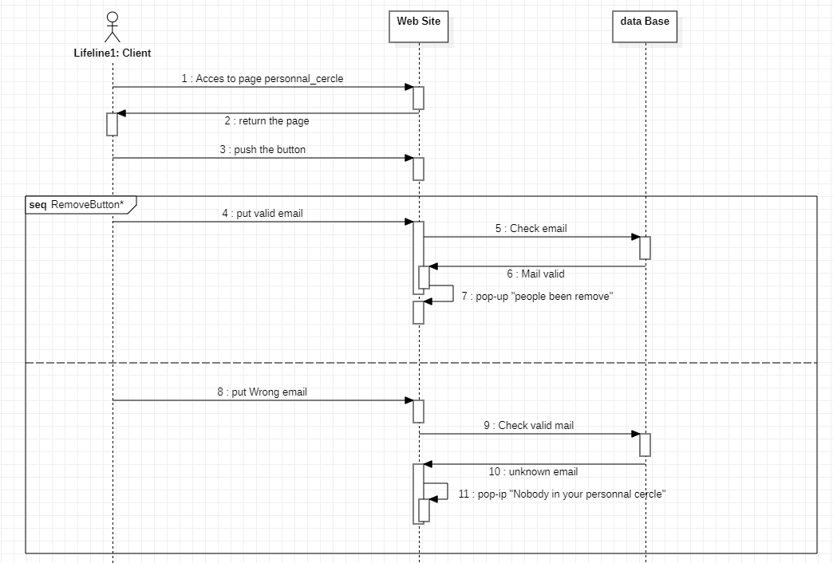

### Insert data

User put email (it will be in her personal circle) and submit

## Object definitions

In this part, we will remove people on the user Personal Circle

### The actors

**User:** The general user of the platform Patient, Nurse, Doctor, Family Member.

**WEB Site:** the web site where the personal circle page is available, it as the “front” of the web site.

**Database:** regroup database and the rest API, it as the “back” of the web site.

### Handle feeling form

#### Use Case Specification

|  |
| --- |
| Use Case: Handle Feeling Form |
| Description: The patient can fill and submit the feeling form |
| Principal actor: Patient |
| Prerequisite: A valid patient is connected to the platform |
| Principal flow:   1. The use case begins when the patient navigates to the feeling form tab when connected. 2. The patient fills all necessary information in parallel    1. Rate tiredness    2. Rate stress    3. Rate happiness    4. Rate anxiety    5. Put some note about current feeling 3. The patient submits the form. |
| Postconditions:   1. The values are saved in database and can be viewable in the health data tab |
| Alternative flow:   1. The user has not filled all needed information. 2. The user loses his connexion before submitting the form. 3. Due to server-side problem, the form values cannot be saved in database. |

##### Alternative flow 1

|  |
| --- |
| Alternative flow: Handle Feeling Form: The user has not filled all needed information. |
| Description: The user has not filled all needed information. |
| Principal actor: Patient |
| Prerequisite: A patient has tried to submit the feeling form, but some information is missing. |
| Flow:   * The alternative flow begins when the user tries to submit the form at step 3. * The system shows a toaster with an error message. * The system highlights invalid or missing input in the form. * The user return to the step 2 of the principal use case. |
| Postconditions: None |

##### Alternative flow 2

|  |
| --- |
| Alternative flow: Handle Feeling Form: The user loses his connexion before submitting the form. |
| Description: The user loses his connexion before submitting the form. |
| Principal actor: Patient |
| Prerequisite: A patient has tried to submit the feeling form, but his connexion was lost before submitting. |
| Flow:   * The alternative flow begins when the user tries to submit the form at step 3. * The system shows a toaster with an error message that says to retry when the connexion is available. * The form will have to be filled and submitted again when the connexion is back. |
| Postconditions: None |

##### Alternative flow 3

|  |
| --- |
| Alternative flow: Handle Feeling Form: Due to server-side problem, the form values cannot be saved in database. |
| Description: Due to server-side problem, the form values cannot be saved in database. |
| Principal actor: Patient |
| Prerequisite: A patient has tried to submit the feeling form, but due to server-side problem, the data cannot be saved in database. |
| Flow:   * The alternative flow begins when the user tries to submit the form at step 3. * The system shows a toaster with an error message that says to retry when the connexion is available. * The form will have to be filled and submitted again when the connexion is back. |
| Postconditions: None |

#### Activity diagram

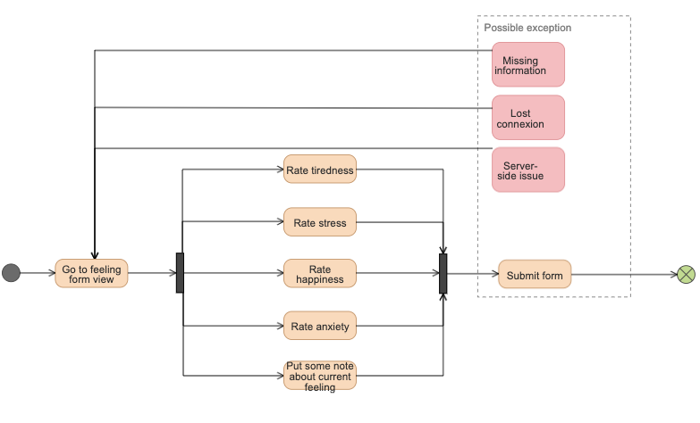

#### Sequence diagram

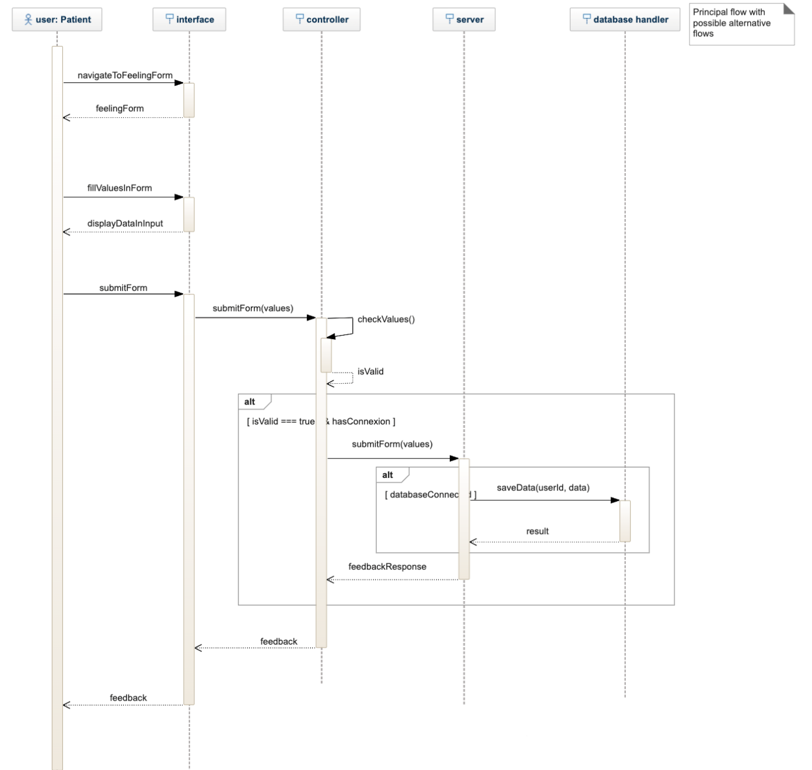

### Insert data

Data comes from sensors that are handled by an external system. We just need to build a job like a cronjob that runs every night to fetch and put data in database for each user.

## Object definitions

In this part, we will define all objects used in our project.

### The actors

**User:** The general user of the platform.

**Patient:** The user that needs to be followed by doctors, nurses, members of family...

**DataReader:** A generic type of user that can read patient health information.

**Doctor:** The doctor is a user who can follow several patients and has access to all the health data of a patient.

**Nurse:** The nurse is a user who can track multiple patients and has access to all the health data of a patient over a short period of time.

**FamilyMember:** A family member is a user who can follow a single patient and can have access to a portion of that patient's health data.

### The type of data

**Personal data:** Personal data of the user.

* Name
* First name
* Sex
* Age
* Weight
* Height
* Email
* Phone number
* Address

**Health data:** The user's health data, this data comes from sensors external to the platform as well as manual completion by the user.

* Heart rate
* Blood pressure
* Personal feeling (manual completion with Feeling form)
  + Fatigue felt (1-5)
  + Felt stress (1-5)
  + Feeling good (1-5)
  + Anxiety felt (1-5)
  + Notes
* Stress level
* Blood oxygenation
* Sleep rhythm
* Body temperature

# SCRUM MASTER

# Code

<https://github.com/IUT-DEPT-INFO-UCA/gp-dam-teamflexsante>

## Register

*As a user, I would like to be able to register on the platform to benefit from the features offered.*

[Main] ✅

[Integration] ✅

[dynamization] ✅

[Back-route] ✅

[Back-Database] ✅

## Login

*As a user, once I have registered, I would like to be able to log in to the platform.*

[Main] ✅

[Integration] ✅

[dynamization] ✅

[Back-route] ✅

[Back-Database] ✅

## Logout

*As a user, after I have used the platform, I would like to be able to logout from the platform.*

[Main] ✅

[Back-route] ✅

[Back-Database] ✅

## Retrieve

*As a user, I would like to be able to retrieve some information about my profile.*

[Main] ✅

[Integration] ✅

[dynamization] ✅

[Back-route] ✅

[Back-Database] ✅

## Add Personal circle

*As a user, I would like to be able to add another user to my personal circle.*

[Main] ✅

[Integration] ✅

[dynamization] ✅

[Back-route] ✅

[Back-Database] ✅

## Submit Data

*As a Patient, I would like to be able to submit data about my health.*

[Main] ✅

[Integration] ✅

[Dynamization] ✅

[Back-route] ✅

[Back-Database] ✅

## See Data

*As a user, I would like to be able to see the data about a patient health.*

[Main] ✅

[Integration] ✅

[dynamization] ✅

[Back-route] ✅

[Back-Database] ✅